

Mobile Area Council 2025



*Tee It Up For Popcorn*

**

*2025 Popcorn Leader Guide*

## Popcorn Kernel Job Description

By accepting the invitation to become your unit's Popcorn Kernel, you are ensuring the sale is a success. Your primary responsibilities are to manage all aspects of the sale, clearly communicate sale information to your leaders, parents, and Scouts, and host a dynamic kick off. Training and documents that will help you prepare for a successful sale will be distributed at the Unit Training Meetings, your August Roundtable, and are available on the council website (scoutingmac.org).

1. Promote the 30% commission plan and attend the July 19th in-person or virtual training meeting for the District Kernels and unit leaders. When you attend the Kickoff and pay on time your unit will receive an additional 5% commission. This will equal a total of 35% commission.
2. Assist in setting up a sales plan for your unit that includes the 3 methods of selling popcorn: Take Order, Show and Sell and Online.
3. Successful Sales Tips
   * Organize and conduct a successful Unit Popcorn Kick Off
   * Communicate the purpose for the sale and timeline to your Scouts and parents.
   * Assist in setting unit and per-scout goals based on your activities calendar.
   * Distribute sales materials to all Scouts and families.
   * Set up Show & Sell locations and dates.
   * Assist in distributing popcorn for Show and Sells.
   * 4. September/October- Follow-up
     + Inspect, coach, and praise your Scouts
4. November / December Ensure all online popcorn and online prize orders are complete in Trail's End system.
   * Distribute Take Order popcorn and collect money from parents.
   * All payments due to the council (total sales - unit commission - payment due council) must be submitted by or before November 21st.

Mobile Area Council Popcorn Prizes 2025

In addition to the prizes offered by Trail's End, the Mobile Area Council is offering:

Weekly Drawings

To be eligible for weekly drawings, you may email, or hand deliver a printout of your Scout's sales report from your mobile app or a copy of your paper order form. All submissions MUST be in the office before 12:00 noon on the below dates of the drawing.

Email: [Sonya.Seabrook@scouting.org](mailto:Sonya.Seabrook@scouting.org)

Sell $250 by August 25th to be entered to win an $25 Amazon Gift Card



Sell $500 by September 2nd to be entered to win an $50 Amazon Gift Card



Sell $750 by September 8th to be entered to win a Day Camp, Resident camp, or Express Camp 2026 Complimentary

Registration

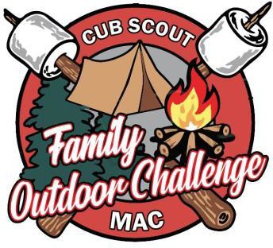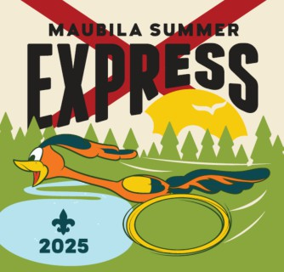

Sell $1000 by September 15th to be entered to win a Day Camp, Resident camp, or Express Camp 2026 Complimentary Registration and a $25 Amazon Gift Card



Sell $2000 by September 22nd to be entered to win one complimentary registration to the National Jamboree

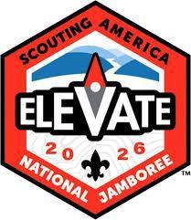

You DO NOT need to resubmit forms already turned in, unless the Scout has additional sales that qualify them for a higher level. Council will automatically move forms to qualifying levels after each drawing. Make sure you have parent and scout's name and a reliable adult phone number on the submitted form

Level Up Club

Scouts who sell $1,500 or more will receive 4 complimentary tickets to the senior bowl.



### District Top Seller

Both Baldwin and Fiver River's Top Seller Scout of at least $12,000 will receive a Top Golf Experience Package.



*Scout's Sales include total amount sold from Take Order, Show & Sell, and Online Sales.

### 2025 Popcorn Sale Timeline

**Saturday, July 19th** Popcorn Training, (Required for possible 35% commission)

Ben May Library

**Friday, AUG. 8th** Deadline to submit Unit's Show and Sell order online.

**Saturday, AUG. 23rd** Units pick up popcorn order* (date may change due to Trail's End)

**Tuesday, AUG. 26th** Units may pick up extra popcorn from Council Service Center as needed, until product is depleted.

**Friday, Oct. 3rd** Unit’s Take Order deadline submission online

**Saturday, Oct. 25th** Units pick up popcorn order* (date may change due to Trail's End)

**Friday, Nov. 21st** All payment due to Council by 5pm. Prizes are released from Trail's End when balance owed is $0.

**Monday, Dec. 2nd** Unit Commission drops to 25%

**Monday, Dec. 8th** Unit commission drops to 15%

*Unit will receive an invoice with orders and payments received.

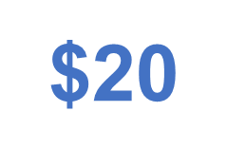 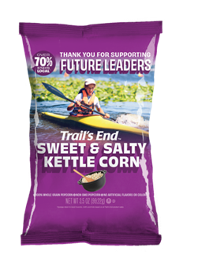

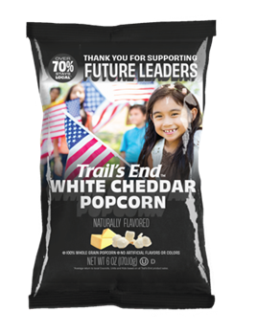

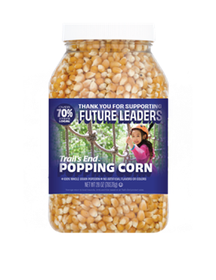Sweet & Salty Kettle corn White Cheddar

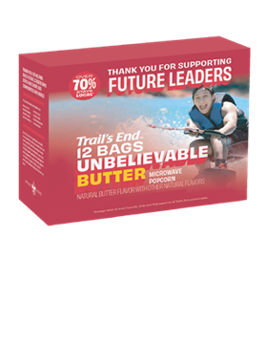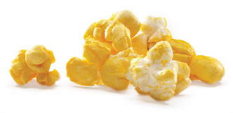

$25

Unbelievable Butter Microwave



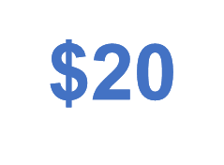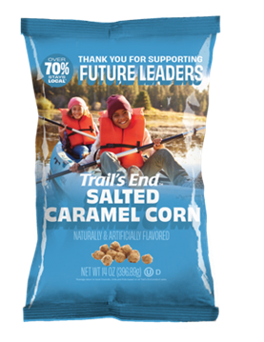

Salted Caramel Corn Popping Corn



COUNCIL’S Contact Information

Sonya Seabrook: Fund Development Specialist and Popcorn Unit's Support

[Sonya.Seabrook@scouting.org](mailto:Sonya.Seabrook@scouting.org) 251-476-4600

Aja Hoyt: District Assistant [Aja.Hoyt@scouting.org](mailto:Aja.Hoyt@scouting.org) 251-476-4600

Mary Phillips: Registrar [Mary.Phillips@scouting.org](mailto:Mary.Phillips@scouting.org) 251-476-4600

District Kernels

Kelly Dunbar: Baldwin District Kernel [kkellytorp@aol.com](mailto:kkellytorp@aol.com)

(251)680-9289

Charles Harris: Five Rivers District Kernel [CharlesHarris2@ccbcu.com](mailto:CharlesHarris2@ccbcu.com)

251-295-1977

Popcorn Order Guide

Use this reference guide for ordering Show & Sell. The cost and amount of pieces per case are listed next to the product.

Remember: Units order Show & Sell inventory by the case; Take Order can be ordered by the individual pieces.

|  |  |  |
| --- | --- | --- |
| Product | Price/ Pieces per case | Amount to order |
| Sweet & Salty Kettle Corn | $15/$180 (12 per case) |  |
| White Cheddar | $ 20/ $240 (12 per case) |  |
| Salted Caramel Corn | $ 25/$300 (12 per case) |  |
| Unbelievable Butter | $25/ $150 (6 per case) |  |
| Popping Corn | $ 20/ $180 (9 per case) |  |



## TRAIL'S END/ Online

JOIN TE FACEBOOK GROUP

Text FACEBOOK to 62771 to join

### JOIN TE WEBINARS

Text WEBINAR to 62771 to register

VISIT TE WEBSITE

[www.trails-end.com](http://www.trails-end.com/)

### EMAIL TE:

[support@trails-end.com](mailto:support@trails-end.com) NEED HELP? VISIT TE FAQs:

support.trails-end.com